Threat Model and Secure Configuration
Prepared by: Anoop Gangadharan
Project: Small Web Application – User Login and Profile Management
Methodology: STRIDE Threat Modelling
Assessment Type: Beginner-level Security Assessment

1. Project Overview
The objective of this project is to identify potential security threats in a small web application and prepare a prioritized security hardening plan.
The application allows users to:
- Register an account.
- Log in securely.
- View their profiles.
- Update profile information.
- Reset forgotten passwords.
The assessment focuses on authentication, authorization, session management, data protection and application security configuration.
2. Application Architecture and Trust Boundaries
2.1 Architecture Components
The application consists of the following components:
- User Browser – Sends requests to the application.
- Web Application – Processes user requests.
- Authentication Module – Handles login and password verification.
- User Database – Stores user information and password hashes.
- Email Service – Sends password reset links.
2.2 Architecture Diagram
flowchart TD
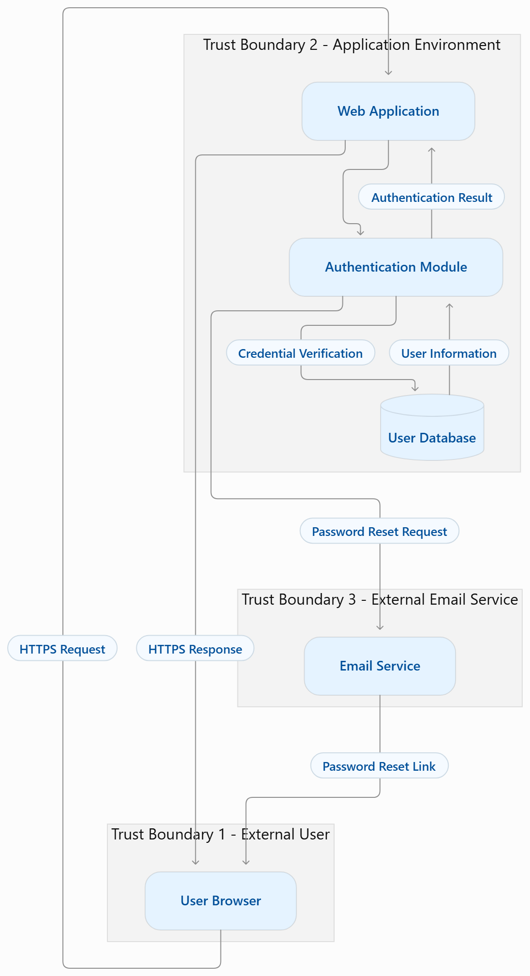

2.3 Trust Boundaries
- User Browser to Web Application: External user requests must be validated.
- Web Application to Database: Database access must be authenticated and restricted.
- Application to Email Service: External communication must be secured.
3. Security Threat Identification – OWASP ZAP
An OWASP ZAP vulnerability scan report dated 06 July 2026 was reviewed to identify potential security issues.
The scan reported 31 alerts across the primary website and associated third-party services.
3.1 Alert Summary
Risk Level | Count
High | 1
Medium | 10
Low | 10
Informational | 10
Total | 31
3.2 Key Security Findings
- Hash Disclosure – SHA-256 Crypt: Potential disclosure of cryptographic material through a Cloudflare challenge endpoint.
- Missing Content Security Policy: CSP header was absent on the challenge-platform response.
- Session ID in URL: Session or tracking identifiers were passed through URL parameters.
- Cookie Scope Issue: A cookie was configured with a broader scope than required.
- Cache-Control Issue: Cache directives may allow sensitive responses to be cached.
- Sensitive Information in URL: Session recording requests included identifiers in URL query parameters.
3.3 Security Considerations
These findings indicate potential information disclosure, session security and security configuration weaknesses.
Further validation is required before confirming exploitability.
The scan included third-party services. Therefore, findings must be assessed in the context of their respective hosts and ownership.
4. STRIDE Threat Modelling
STRIDE is a threat modelling methodology used to identify six categories of security threats.
STRIDE Category | Potential Threat | Impact
Spoofing | Attacker uses stolen credentials to access an account | Account takeover
Tampering | Unauthorized modification of profile information | Data integrity loss
Repudiation | Missing audit logs for user activities | Lack of accountability
Information Disclosure | Unauthorized access to another user's profile | Privacy breach
Denial of Service | Excessive requests overload the application | Service disruption
Elevation of Privilege | Normal user accesses administrator functionality | Unauthorized control
5. Risk Assessment and Prioritization
Risk scores are estimated using:
Risk Score = Likelihood × Impact
Scoring scale:
- 1–4: Low
- 5–9: Medium
- 10–16: High
- 17–25: Critical
5.1 Risk Assessment Table
Threat | Likelihood | Impact | Score | Priority
Account takeover | 4 | 5 | 20 | Critical
IDOR / Unauthorized profile access | 4 | 5 | 20 | Critical
SQL Injection | 3 | 5 | 15 | High
Privilege escalation | 3 | 5 | 15 | High
Denial of Service | 3 | 4 | 12 | High
Missing audit logs | 3 | 3 | 9 | Medium
These are preliminary estimates for the example application, not confirmed vulnerabilities.
6. Prioritized Security Hardening Plan
Priority 1 – Critical Security Controls
- Implement strong authentication.
- Store passwords using secure password hashing such as Argon2id or bcrypt.
- Enforce server-side authorization checks for every profile request.
- Prevent IDOR by ensuring users can access only their authorized records.
Priority 2 – High Security Controls
- Use parameterized SQL queries to prevent SQL injection.
- Implement secure session management.
- Apply rate limiting to login and password reset endpoints.
- Implement proper role-based access control.
- Maintain audit logs for important security events.
Priority 3 – Additional Security Improvements
- Enforce HTTPS across the application.
- Configure secure cookie attributes: HttpOnly, Secure and SameSite.
- Implement an appropriate Content Security Policy.
- Avoid exposing sensitive information in URL parameters.
- Configure suitable Cache-Control headers.
- Regularly update application dependencies and security patches.
7. Security Testing and Validation Plan
The following tests can be performed in an authorized local or mock environment.
Test Case | Security Objective | Expected Result
Invalid login | Test authentication | Login denied
Access another user's profile | Test authorization / IDOR | Access denied
SQL injection input | Test input handling | Malicious input rejected or safely handled
Session cookie inspection | Test session security | Secure cookie attributes configured
Excessive login attempts | Test rate limiting | Requests restricted
Audit log verification | Test accountability | Security events recorded
Tools
- OWASP ZAP – Web application vulnerability scanning.
- Burp Suite – HTTP request and response analysis.
- Kali Linux – Security testing environment.
All testing must be performed against systems for which authorization has been obtained.
8. Conclusion
This threat modelling exercise identified potential security risks in a small web application that supports user registration, authentication, profile management and password reset functionality.
Using the STRIDE methodology, six major threat categories were considered.
The risk assessment prioritized account takeover and unauthorized profile access as critical concerns.
The proposed security hardening plan focuses on authentication, authorization, secure session management, input validation, data protection and security monitoring.
Further practical testing and manual validation are necessary to confirm vulnerabilities and verify that the recommended security controls are effective.

